**From Observation to Analysis**

**Plotting the Orbit of Mars from Planetarium Observations**

**Instructor’s Notes:**

Project Physics was a post-Sputnik high school physics curriculum. It was created at Harvard University in the 1960s and early 1970s and was used in classrooms through the 1980s. It included many hands-on projects such as the determination of the orbit of Mars through direct analysis of photographs of Mars in orbit around the sun.

The Mars project utilized photographs of Mars taken at intervals equal to one Mars sidereal period, placing Mars in the same relative position using heliocentric coordinates. Carefully chosen dates placed the earth in nearby positions, allowing astronomers to triangulate on the position of Mars as seen below.

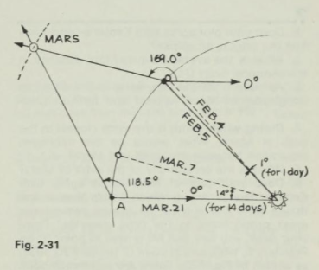

Page 69 of the Project Physics handbook

The original project used photographs of Mars and provided transparent overlay grids to determine geocentric ecliptic longitude. The photos and transparencies are no longer in print. However, using simulation software or a planetarium, it is possible to recreate the measurements from the original project and use them to plot an orbit for Mars. In our first attempt we used the right ascension and declination of Mars in reference to nearby known stars. That was because no ecliptic coordinate grid was available in the software we were using. The software provides ecliptic longitude but does not allow students to obtain the values by estimation.

In our version since we used the RA and Dec of the planet instead of the ecliptic longitude, our orbit will be projected onto the equatorial plane making the estimate of the eccentricity of the orbit incorrect.



If you used right ascension coordinates instead of ecliptic longitude, your orbit is tilted with respect to the ecliptic plane. Assuming Mars’ orbit is coplanar with the ecliptic and the ecliptic is tilted 23.5 degrees with respect to the celestial equator, this means that the orbit of Mars will be a projection onto the ecliptic plane, making the semi-major axis appear slightly shorter than it really is. The simplified relationship is $a_{Ecl}=\frac{a_{RA}}{cos⁡(23.5)}$. (It turns out that the perihelion of Mars is somewhat aligned with the equatorial coordinate system origin making this estimate reasonable.)



Use this adjusted value in your calculations to improve the estimate of the eccentricity. Interestingly, the minor axis is not affected. A more sophisticated analysis using spherical trig and using the declination values is probably beyond the scope of an introductory astronomy class.

Final results:

The plot, when completed with equatorial coordinates, looks like this:

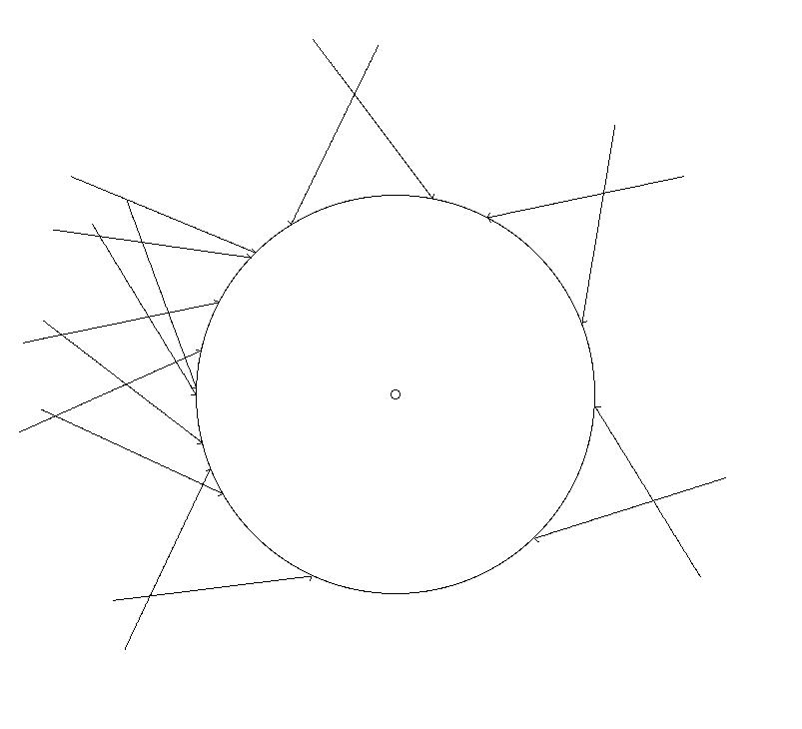

When the student smoothly connects the dots to create an ellipse representing the orbit of Mars the drawing should resemble this:

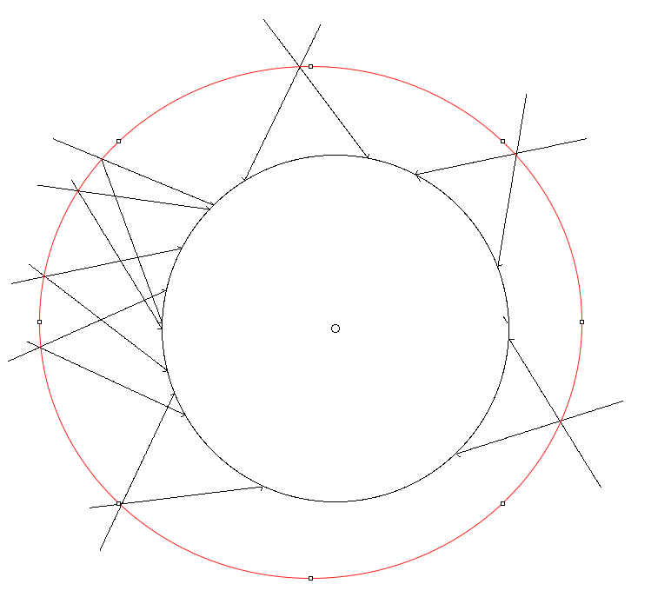

Based on these measurements and the drawing above, the following answers are obtained:

a = 311.5 pixels

sun is 341 pixels from left edge

c = sun – a = 30.5 pixels

eccentricity = c/a = 30.5 / 311.5 = 0.098 (accepted value is 0.093)

If we apply the estimated semi-major axis correction we get a = 339, leading to an eccentricity of 30.5/339= 0.089. This shows the RA to ecliptic coordinate transformation is not a big barrier to getting reasonable results.

Implementation in class:

It may be more time effective to assign small teams of 2 to each pair of dates and have them construct the angles on a master plot. Alternatively all the data can be shared and small groups of 4 can construct a master plot using all the data.

Assumptions:

It is assumed students can use a protractor, have access to a calendar, calculator or a spreadsheet, and understand right ascension. Students should have already drawn an ellipse and determined its eccentricity prior to this activity using e = c/a.

It is possible to do the activity with computers or projectors without a planetarium. However, part of the purpose of the activity is to relate how real-world observations connect to the abstract concept of an elliptical orbit observed from the plane of the orbit.

References:

* <https://archive.org/details/projectphysicsha00fjam>
  + This is an archive of the Project Physics materials including the original instructions for this site:
* <http://dev.physicslab.org/Document.aspx?doctype=2&filename=UniversalGravitation_MarsOrbit.xml>
  + Catharine Colwell created a page on her site that contains instructions adapted from the original Project Physics lab, including the dates of the observation of Mars from the earth. These instructions are adapted from her web site and are used with permission.
* http://www.stellarium.org
  + This is the software used to recreate the observations in our planetarium.

Notes from presentation:

* Galileo by Brecht: To perform: <http://www.samuelfrench.com/p/734/life-of-galileo-the-hare-trans>
* Celestia space simulator: <http://www.shatters.net/celestia/index.html>
* Lawrence Hall of Science Planetarium Activities for Successful   
  Shows:  http://www.planetarium-activities.org
* Cardboard Planetarium site: [www.cccoe.net/stars](http://www.cccoe.net/stars)

Jeff Adkins

[astronomyteacher@mac.comb](mailto:astronomyteacher@mac.comb) c

**Orbit of Mars**

**Student Instructions and Worksheet**

**Materials needed:**

* Large sheet of poster board or poster paper (~ 1 m2)
* Protractor (preferably 360 degrees)
* Planetarium with planet simulator (for example, Stellarium in a fisheye projector)
* Ruler (meterstick)
* String and pushpin or large whiteboard compass
* Spreadsheet or calculator
* Pencil with eraser

**Part A: Prepare the poster for plotting**

1. Lay out the poster on a large table so it is flat. Mark a point near the center and label it “SUN.”
2. Draw a circle 20 cm in radius centered on the sun. This circle will represent the earth’s radius. Use a push pin and string, or a large compass. The earth’s orbit is not really a circle but it is close enough not to matter for the purposes of this activity.
3. Celestial coordinates are based on the position of the sun in the sky on the Vernal (Spring) Equinox. That is essentially zero in our coordinate system. To keep things simple, we are going to use a point on the left of the circle to represent the position of the earth during the Vernal Equinox on March 21. All other dates involved in this project will be counted from this position. Find this position and label it March 21.



**Part B: Determine where the Earth was on selected dates**

1. In the table below, determine how many days (and thus, how many degrees) the Earth was from its zero position by counting the number of days from March 21 until the date indicated. If you want to be more precise, multiply the number of days by 360/365.24 to find the angle. This is because you are converting days to angles at the rate of 360 degrees for 365.24 days in a year.

Table . Position of Earth on Selected Dates

|  |  |  |  |
| --- | --- | --- | --- |
| Position | Date | Number of Days since March 21 | Angular separation from March 21 |
| A | March 21 | 0 | 0 |
| B | February 5 |  |  |
| C | April 20 |  |  |
| D | March 8 |  |  |
| E | May 26 |  |  |
| F | April 12 |  |  |
| G | September 16 |  |  |
| H | August 4 |  |  |
| I | November 22 |  |  |
| J | October 11 |  |  |
| K | January 21 |  |  |
| L | December 9 |  |  |
| M | March 19 |  |  |
| N | February 3 |  |  |
| O | April 4 |  |  |
| P | February 21 |  |  |

1. Moving around the circle counterclockwise, mark all of the angles in your table showing where the Earth was on those dates. Here’s how you should hold your protractor when measuring these angles:



**Part C: Determine the RA of Mars on each date and convert the RA to degrees**

This part of the project takes place in the planetarium. You could also do it with planetarium software on a desktop computer, but using the planetarium helps convey the connection between the real-world observation and the abstract information we are collecting.

The dates listed (including the year) come in pairs. The dates are separated by one Martian sidereal period. This places Mars in the same location relative to distant stars. However, the earth is not in the same position. It will be in a different place, allowing us to triangulate on the position of Mars as shown here.

Table . Direction of Mars on Selected Dates

|  |  |  |  |
| --- | --- | --- | --- |
| Position | Date | RA (h,m) of Mars | RA converted to degrees |
| A | March 21,1931 |  |  |
| B | February 5,1933 |  |  |
| C | April 20,1933 |  |  |
| D | March 8,1935 |  |  |
| E | May 26, 1935 |  |  |
| F | April 12,1937 |  |  |
| G | September 16,1939 |  |  |
| H | August 4,1941 |  |  |
| I | November 22,1941 |  |  |
| J | October 11,1943 |  |  |
| K | January 21,1944 |  |  |
| L | December 9,1945 |  |  |
| M | March 19,1946 |  |  |
| N | February 3,1948 |  |  |
| O | April 4,1948 |  |  |
| P | February 21,1950 |  |  |

1. For the dates listed in the table, ask the planetarium operator to set the date to the one given, and then rotate the view so Mars is visible. Also ask for the equatorial coordinate grid to be activated so you can see the RA and dec numbers on the scale. If you have a digital planetarium you may be able to “zoom in” to be more precise. It does not matter where on Earth the simulation is set or what time it is as long as it is dark and Mars is visible. (It won’t move much in a day and everyone on Earth sees about the same thing.)

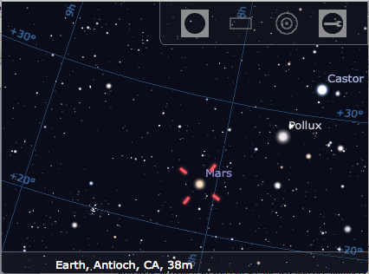

1. Using the equatorial grid, estimate the RA of Mars for that date and add it to the table. You don’t need the declination for this experiment. Remember each hour of RA is subdivided into 60 minutes. Half an hour is 30 minutes, and so on. Also note that RA increases to the LEFT on the chart, rather than to the right as in a traditional graph. As you can see in this example the RA of Mars on March 21, 1931 is approximately 8 hours and about 9 minutes. (NOTE: If ecliptic longitude is available through your software, use that instead.)
2. Now move through the other dates and complete the table.
3. After you have finished, you will need to convert the RA readings into degrees using the following formula:

$$angle=\frac{(RA hours+\frac{RA minutes}{60})}{24} × 360°$$

You might find a spreadsheet useful for this kind of work.

When the table is complete you are ready for the next step.

**Part D: Plotting the orbit of Mars**

The coordinate system used in astronomy points to the Vernal (Spring) equinox position of the sun on March 21. This reference point, where the ecliptic crosses the celestial equator as the sun heads into Spring, is defined to be zero hours Right Ascension (RA). RA increases counterclockwise around this position.

1. To see how it works, look at your poster where you marked March 21. This is where the Earth is on that date. Draw a light line between that point and the Sun and label it 0 h RA.



Place your protractor with the earth at the vertex and aim zero at the sun as shown below. Now look at the chart you created and see where Mars was on March 21, 1931. In our example, the RA of Mars on that date was 8 h 9 m. When we convert this to an angle we get

$$angle=\frac{(8+\frac{9}{60})}{24} × 360°=122°$$

1. Now put your protractor with the vertex on the earth, zero aligned with the sun, and measure an angle of 122 degrees counterclockwise from that line as shown. Draw a sight line in that direction. As seen from Earth on that day, that is where the planet Mars appeared to be.



1. You are now going to repeat this process with every other date in your table. As you change dates, you will need to mark the new position of the Earth based on Table 1 and measure the sight line to Mars based on Table 2. Each time, make a new zero line parallel to the first one each time as shown below.



Draw lightly so you don’t get too many heavy lines in your figure. Label each sight line so you can keep track of which ones you’ve completed. Note: If the angle is greater than 180 degrees, flip over your protractor and keep measuring. Here is where having a 360 degree protractor might be easier.

Each pair of dates should cause an intersection that looks something like this:



It should not intersect inside the Earth’s orbit. That means you’ve done something wrong. Check your measurements, your math, and double check your drawing before asking for help.

**Step E: Connect the dots and finish**

1. Now using a piece of string, determine where the major axis of Mars’ orbit lies. Remember the major axis is the widest part of the orbit, and the line must go through the center (the sun).
2. Measure the major axis and divide its length by two. Mark the center of the major axis “c.” Half of the major axis is called the semi-major axis, or variable “a” in formulas. Label the major and semi-major axes, and measure the semi-major axis and record it below.

a = _________________________________

Note: If you used RA coordinates, you must adjust your value using $a_{Ecl}=\frac{a_{RA}}{cos⁡(23.5)}.$ If you used ecliptic longitude coordinates do not adjust your value.

a (adjusted) = _______________________________________

1. Now draw a line perpendicular to the major axis, passing through the center of the major axis. This is the minor axis. Label it.
2. Measure the distance from c to the sun. This is called the focal length, and is usually labeled “c” in astronomy formulas. Label the focal length on your diagram.
3. Calculate the eccentricity of Mars’ orbit. This is computed using the formula

e = c/a. =________________________________

1. Convert the major axis of Mars’ orbit to Astronomical Units (AU). This is computed by taking

$$a_{Mars (AU)}=\frac{a_{Mars} \left(cm\right)}{1}×\frac{1 AU}{20 cm}$$

Mars’ orbit eccentricity converted to AUs: __________________________

1. Both the eccentricity of Mars’ orbit and the semi-major axis in AU is available from any standard reference or the internet. Compute your relative error and answer the questions below to complete this assignment. Recall relative error equals $R.E. = \frac{Accepted Value-Measured Value}{Accepted Value}x100$

Accepted Value for eccentricity (and source) : ________________________

Accepted Value for semi-major axis (and source): _________________________

Relative Error for eccentricity: ___________________________

Relative Error for semi-major axis: ____________________________

**Student Reproducible Answer Sheet**

Use this sheet to capture student answers and use less paper when copying.

Table 1.

|  |  |  |  |
| --- | --- | --- | --- |
| Position | Date | Number of Days since March 21 | Angular separation from March 21 |
| A | March 21 | 0 | 0 |
| B | February 5 |  |  |
| C | April 20 |  |  |
| D | March 8 |  |  |
| E | May 26 |  |  |
| F | April 12 |  |  |
| G | September 16 |  |  |
| H | August 4 |  |  |
| I | November 22 |  |  |
| J | October 11 |  |  |
| K | January 21 |  |  |
| L | December 9 |  |  |
| M | March 19 |  |  |
| N | February 3 |  |  |
| O | April 4 |  |  |
| P | February 21 |  |  |

Table 2.

|  |  |  |  |  |
| --- | --- | --- | --- | --- |
| Position | Date | RA (h,m) of Mars | RA converted to degrees | Ecliptic Longitude (if available) |
| A | March 21,1931 |  |  |  |
| B | February 5,1933 |  |  |  |
| C | April 20,1933 |  |  |  |
| D | March 8,1935 |  |  |  |
| E | May 26, 1935 |  |  |  |
| F | April 12,1937 |  |  |  |
| G | September 16,1939 |  |  |  |
| H | August 4,1941 |  |  |  |
| I | November 22,1941 |  |  |  |
| J | October 11,1943 |  |  |  |
| K | January 21,1944 |  |  |  |
| L | December 9,1945 |  |  |  |
| M | March 19,1946 |  |  |  |
| N | February 3,1948 |  |  |  |
| O | April 4,1948 |  |  |  |
| P | February 21,1950 |  |  |  |

1. Semi-major axis a = _________________________________

Note: If you used RA coordinates, you must adjust your value using $a_{Ecl}=\frac{a_{RA}}{cos⁡(23.5)}.$ If you used ecliptic longitude coordinates do not adjust your value.

1. Calculate the eccentricity of Mars’ orbit. e =___________________________

Please explain your method for obtaining e.

1. Mars’ orbit eccentricity converted to AUs: __________________________
2. Accepted Value for eccentricity (and source) : ________________________

Accepted Value for semi-major axis (and source): _________________________

Relative Error for eccentricity: ___________________________

Relative Error for semi-major axis: ____________________________